**Setting Up and Exposing a Service in Minikube**

### **Steps Performed:**

**Checked Minikube Status**  
minikube status

**Started Minikube**minikube start

**Tried to Get the Service URL (Failed Initially)**

minikube service nginx-service --url

**Checked Available Services**kubectl get services --all-namespaces

**Exposed the Deployment as a Service**kubectl expose deployment nginx-login --type=NodePort --name=nginx-service

**Retrieved the Service URL**minikube service nginx-service --url

Successfully obtained: http://192.168.49.2:31464

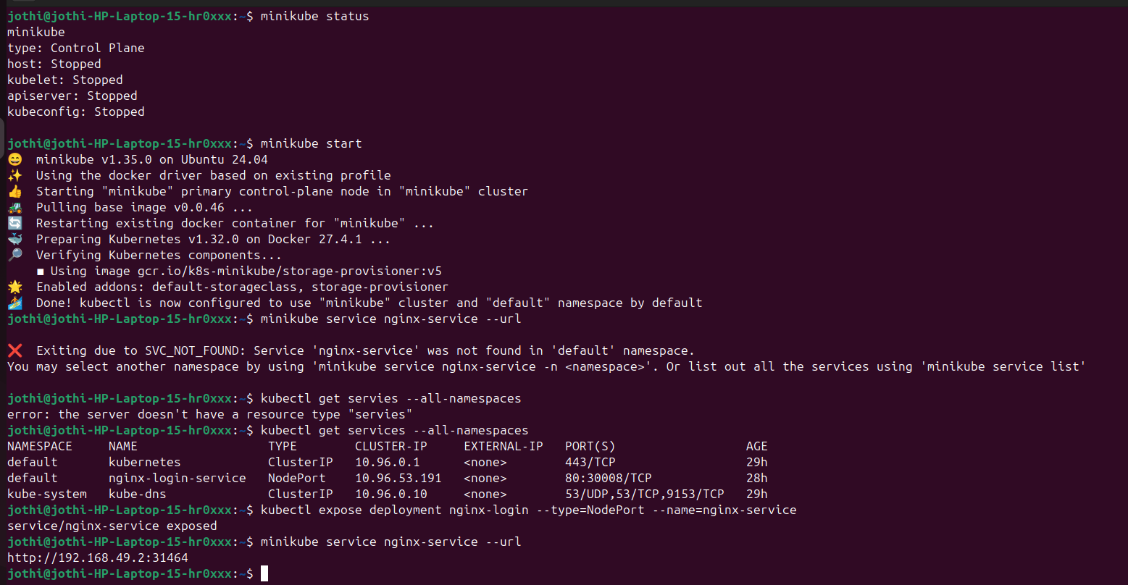

Using **http://192.168.49.2:31464**

